Top tips for building your Wiki
Some Wiki Buddy top tips that we use all the time with our own Wikis:
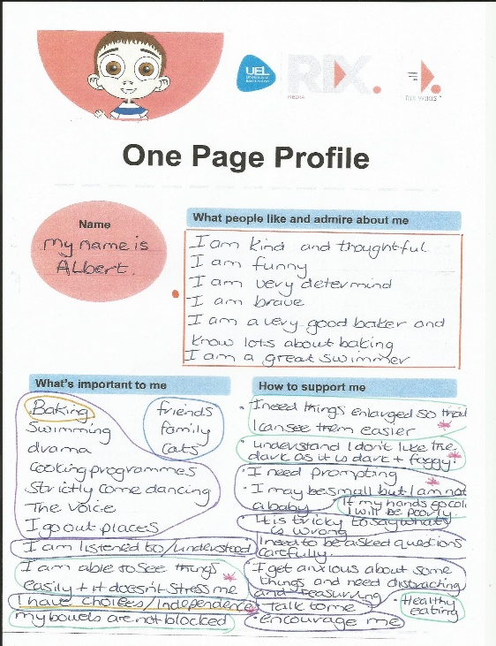
ONE PAGE PROFILE
Planning is essential! This is the most important step and cannot be underestimated - take time to plan.
A One-Page Profile is a good starting place where you can see what’s essential to include; what’s important to your child, what people like and admire about them and how they like or need to be supported. It helps to organise information into sections and gives goals to work towards making progress easier to review.

We have provided an example of a One Page Profile of an imaginary young boy called Albert.

WIKI TEMPLATE
Each new Wiki will be set up with a template to help give ideas about what you can add to each section. We will set up a Big Wiki for you – this allows you to add subsections at any point if you choose to.
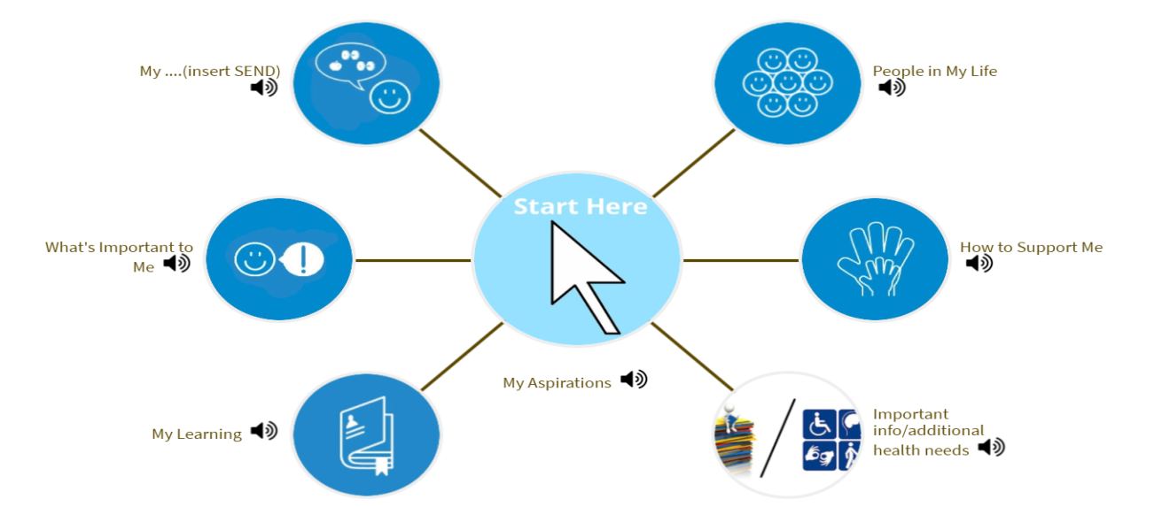

BLANK PLANNING TEMPLATE

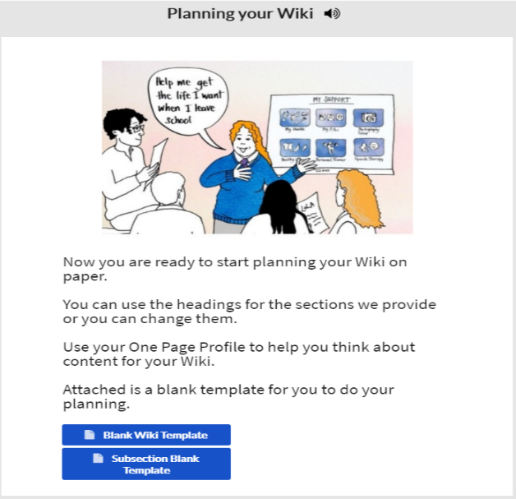
Every person is different, and you may want to redesign the Wiki so that it fits your child better.

There is a blank Wiki template and a blank subsection template available – please contact SENDCommissioningTeam@westsussex.gov.uk if you would prefer a blank template.

This Photo by Unknown Author is licensed under CC BY-SA
Questions to ask when planning theWiki
- What information do people need to know about your child in order to help them and understand them better?
- What does the world look like and feel like for them?
- How can you best describe or show what certain conditions are like to live with every day and how others can very simply make life/appointments so much easier?
- If so what can they do to make it easier – this can be shown via pictures/videos/sound/website links/documents or reports.
- Everything chosen to be included should have a meaning to both you as a family and to those that are invited to view the Wiki. For example, don’t just list your child’s friends or pets, explain why these people/pets are important to your child. If possible, ask the friends if they can be filmed saying what they like and admire about your child. Film your child with their cat/dog to show the importance of their relationship.
GENERAL TOP TIPS – AFTER THE PLANNING STAGE

- When you start building your Wiki it may seem complicated but there’s lots of help available:
  - use the on-screen “click here for help” in the bottom right-hand corner of the screen on the https://wiki.rixwiki.org/ website;
  - refer to the Training Wiki that you have access to on your dashboard;
  - or ask for a Wiki Buddy to come and help you by emailing wikibuddy@wspcf.org.uk. We’re here to help you!
- Make use of the RIX WIKI email helpline and teaching resources on the RIX website. RIX are really helpful and get back to you very quickly (if they haven’t replied please check your junk mail as the reply may be there).
- Give yourself time as it can take time to input information.
- Make a separate folder on your computer or tablet where you save all photos or reports for your child. It’s easy to regularly update your Wiki when you have everything in one place.
- Make life easier for yourself by getting savvy with collecting photos and reports and converting them to electronic files! Download Office Lens and Genius Scan (free apps) onto your phone and use them all the time. These apps are great for scanning documents (single pages or whole documents) or taking pictures of big posters, converting them to electronic files which you can readily save and upload onto your Wiki. These apps will save your life!
- Use a reliable WIFI connection when inputting information
- It's your child's Wiki so involve them if you can and use videos of them introducing their Wiki and themselves etc. This will also give those that view the Wiki a much broader image of who your child is.
- Request email addresses from professionals that work with/support your child so that you are able to share the Wiki with them. NHS Professionals in West Sussex are able to have an invitation sent to their personal work email as opposed to the team/group email that you normally need to use – talk to them about this.
- Upload letters, reports etc as they arrive as this will keep it up to date or put them into a special Wiki folder on the computer so you know where to find them. Always date files when you upload them.
- Remember you can share information/invite a specific person to either view all or only certain sections of the Wiki. If they then no longer work with your child, simply delete the invite.
- Don’t be afraid to ask friends, family and professionals to contribute to the Wiki in any way in which they feel comfortable.
- Share your Wiki in good time so health and other professionals have time to review it prior to appointments or important meetings.
- Come along to a Wiki Wednesday to network with others, learn new tips, receive help if needed and meet the Wiki buddies so you know who can help you.
- Spread the word about Wikis

