Coproduction case studies:
Chat Health Poster
The ‘Chat Health’ text service for 11-to-19-year-olds was keen to connect with young people in West Sussex with Special Education Needs and Disabilities (SEND).
As part of this, Carole Whiley (Healthy Child Programme Area Manager) approached Rachel Sadler (SEND Participation Lead) to work with young people on the Chat Health poster.
The aim was to produce a more accessible, customer-centred version, designed with young people for young people.
Young people from West Sussex youth groups and schools were involved in every stage of the design brief, including ideas for images, font and colour schemes.
Young people told us they wanted a poster with clear text and font, eye-catching colours and images that explain the service and appeal to their age group.
Using a design from Leicestershire as inspiration and feedback from young people, the final design was co-designed with the ‘Young Voices 4 You’ group, who sent their ideas to the NHS graphics team to be mocked up into two posters. Below you can see the final design chosen...
The new poster will be coming to a building near you soon. While a project like this can take a while to get right, it was worth the wait.
A huge thank you to the students and young people who took part from Oak Grove College, the M8s youth groups, The Regis School and Young Voices 4 You.
Find out more information on the Chat Health and Healthy Child Programme.
To read about this project and other participation work with young people in West Sussex, take a look at our accessible Wiki website.
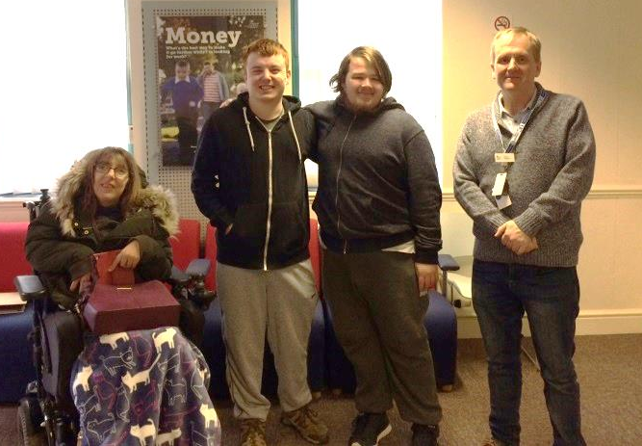
Young Voices 4 You project and tool kits
What started as an idea to re-design our ‘Young Inspectors’ tool kit for young people with Special Education Needs and Disabilities (SEND, has grown and offered young people and services an opportunity to work together to shape a project right from the very beginning.
It began with participation staff and young people from across West Sussex joining together last year, - to discuss how young people can feed back on the services they use, how this feedback would be used and what we felt was important about services and young people working together in this way.
Using these ideas as a design brief, some new tool kits were co-produced for gathering young people’s feedback and a process for using them. The co-produced tool kits and guides were taken to the Short Breaks Provider forum and tested with visits to IPEH services.
Providers said they wanted more quotes from young people and to hear more about their impressions of a service. We listened to what providers said and acted on this by making the tool kits clearer, simpler and more focussed around the experience of young people.
The new and improved toolkits have been tested on a visit to a Job Centre Plus and will continue to be developed using feedback from young people, services and providers.
Those involved created their own artwork for the group and named themselves ‘Young Voices 4 You’ after sharing a poll on their top four name choices.
Young Voices have since been involved in other co-production projects including online information for young people, delivering workshops for practitioners and making a video for the Life Long Service Cabinet Members Day.
Take a look at our Participation Wiki website for updates and examples of the group’s work.
If you would like the ‘Young Voices 4 You’ group to work with your service, know a young person who would like to get involved in the project or would like to know more, please contact rachel.sadler@westsussex.gov.uk or call 07734 000401.

