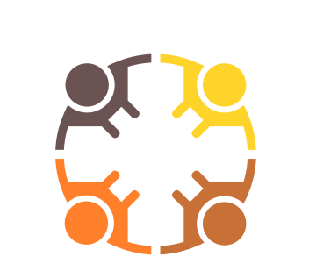
West Sussex County Council
Education, Health and Care Plan (EHCP)
Annual Review Parent Contribution

Your contribution to this Annual Review will be at the core of the meeting along with your child/Young Person’s contribution. Your contribution is essential to make the review the best it can be.

Does your child have:
A Wiki |  | A PATH |  | A Map
Other Person centred approach (please give details):

What is working well?

This could include progress you have seen at home, clubs they attend, outside interests, friendships or relationships, independence, self esteem, behaviour, learning, physical/sporting achievements, support in the setting, communication.

What are your aspirations for your child for the coming year and beyond?

What would be better if…?

This could include progress, behaviour, provision, communication, support they receive, other people who help your child/YP, any needs you feel need more support, things you would like to know more about.
Questions I want to ask

You can ask any questions here which you would like to discuss at the meeting.

Changes to information

Please discuss at the meeting any new medical report, diagnosis, changes to personal information (Name; address; phone number) medical needs, social care needs, changes in circumstances. If there are new reports from professionals please make these available to the setting before the review meeting.

People and Professionals involved with our family

Please add people and professionals who support your family or your child. You may wish to bring a contribution/report from them to the meeting.
Name | Profession/organisation | Contact details (if appropriate)

You can find information and support at
www.westsussex.local-offer.org

